How to create V1 CMGt Deployment User Story

* Assume end-users familiar with VersionONE
* Replace data specific to individual Team Projects

**Acceptance Criteria**

Deployment Story updated with details about the deployment:

* **Title:** Update with Deployment Date and Short Description
* **Project:** Select appropriate CMGt project
* **Sprint:** Select sprint in which deployment will occur
* **Team:**  Do not change; leave as CMGt Deployments
* **Description:** Enter descriptive info about the deployment
* **Upstream Dependencies:** Link Development User Stories that are part of the deployment as Upstream Dependencies

Deployment performed and verified in Production environment (i.e. YSIYRI)

* CMGt Deployment User Story status updated to Accepted
* CMGt Deployment User Story status updated to closed

STEP 1: Click on VersionONE URL link <https://www3.v1host.com/CoxMediaGroup61/Default.aspx?menu=TemplatesPage&feat-nav=m1>

STEP 2: Select CMGt Deployment<yyyy-mm-dd><short description> click Generate User Story and select Generate User Story

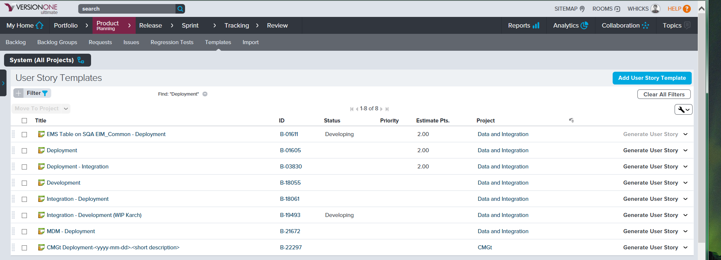

STEP 3: Edit and provide all information listed in **DESCRIPTION** field based on **Acceptance Criteria**

